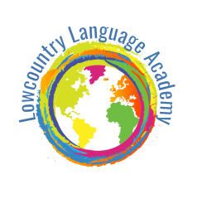
Lowcountry Language Academy
www.Lowcountrylanguage.com
843.442.5683
681 McCants Dr, Mt Pleasant, SC 29464
(Located at Coastal Christian Preparatory School)

Lunch con los Amigos 2018-2019

"Explore the language and culture, with hands-on learning in Science, Math, Engineer, Art and Literacy"

. "Lunch con los Amigos" at Lowcountry Languge Academy is an optional after school program. Children are welcome to stay and have lunch with their friends. The Spanish language will be reinforced while the children are eating and socializing with "los amigos." Your child will enjoy extra play time outside or inside the classroom after finishing with lunch. You can register on a month-to-month basis or pay by the day. Parents are asked to provide their children with healthy, nutritious snacks lunch. *We are offering "Lunch con los Amigos" on Tuesdays and Wednesdays at this time.

Register for ________________________________________________________, 2018
Register for ________________________________________________________, 2019

Day | Time | Monthly Fee | Check your selection
Tuesday | 12: 00 pm - 12:45 pm | $30
Tuesday  (after soccer shots) | 12:30 pm - 1:15 pm | $30
Wednesday | 12:00 pm -12:45 pm | $30
Tuesday and Wednesday |  | $50.00

Child’s Last Name ________________________________ Child’s First Name________________________________________________________

_____________________________________ ________________________________________
Signature of Parent /guardian Date

